Experiment No. 7

Name : Qasim Kharodia SY IT
Roll No : 25

PROGRAM:

DSF
#include <stdio.h>
#include <stdlib.h>

#define MAX_VERTICES 20

int source, V, E, visited[MAX_VERTICES], G[MAX_VERTICES][MAX_VERTICES];

void DFS(int vertex) {
printf("%d -> ", vertex + 1);
visited[vertex] = 1;

for (int j = 0; j < V; j++) {
if (G[vertex][j] == 1 && !visited[j]) {
DFS(j);
}
}
}

int main() {
int v1, v2;

printf("\t\t\tGraphs\n");
printf("Enter the number of edges: ");
scanf("%d", &E);

printf("Enter the number of vertices: ");
scanf("%d", &V);

for (int i = 0; i < V; i++) {
for (int j = 0; j < V; j++) {
G[i][j] = 0;
}
}

for (int i = 0; i < E; i++) {
printf("Enter edge (format: V1 V2): ");
scanf("%d %d", &v1, &v2);

if (v1 >= 1 && v1 <= V && v2 >= 1 && v2 <= V) {
G[v1 - 1][v2 - 1] = 1;
G[v2 - 1][v1 - 1] = 1; // If your graph is undirected
} else {
printf("Invalid input. Please enter valid vertices.\n");
i--; // Decrement 'i' to re-enter the edge
}
}

printf("Adjacency Matrix:\n");
for (int i = 0; i < V; i++) {
for (int j = 0; j < V; j++) {
printf("%d ", G[i][j]);
}
printf("\n");
}

printf("Enter the source vertex: ");
scanf("%d", &source);

if (source >= 1 && source <= V) {
printf("DFS Traversal starting from vertex %d:\n", source);
DFS(source - 1);
} else {
printf("Invalid source vertex.\n");
}

return 0;
}

OUTPUT:

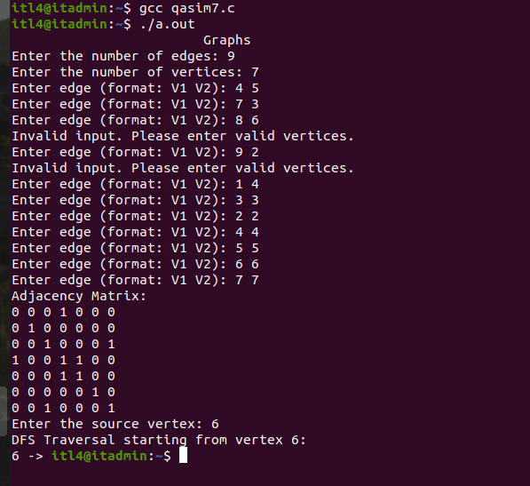

BSF

PROGRAM:

#include <stdio.h>
#include <stdlib.h>

#define MAX_VERTICES 20

int a[MAX_VERTICES][MAX_VERTICES], q[MAX_VERTICES], visited[MAX_VERTICES], n, f = -1, r = -1;

void bfs(int v) {
int i;
for (i = 0; i < n; i++) {
if (a[v][i] != 0 && visited[i] == 0) {
r = r + 1;
q[r] = i;
visited[i] = 1;
printf("%d ", i);
}
}
f = f + 1;
if (f <= r) {
bfs(q[f]);
}
}

int main() {
int v, i, j;
printf("\n\t\t\tBreadth-First Search (BFS)\n");
printf("\nEnter the number of vertices: ");
scanf("%d", &n);

for (i = 0; i < n; i++) {
visited[i] = 0;
printf("\nEnter graph data in matrix form for vertex %d:\n", i);
for (j = 0; j < n; j++) {
scanf("%d", &a[i][j]);
}
}

printf("\nEnter the starting vertex: ");
scanf("%d", &v);

if (v >= 0 && v < n) {
f = r = 0;
q[r] = v;
visited[v] = 1;
printf("BFS Traversal starting from vertex %d:\n", v);
printf("%d ", v);
bfs(v);

if (r != n - 1) {
printf("\nBFS not possible\n");
}
} else {
printf("Invalid starting vertex.\n");
}

return 0;
}
OUTPUT:

